**Assignment 7**

**Name :** Prasad Thorve

**Roll no. :** BC41

Selenium Grid Installation

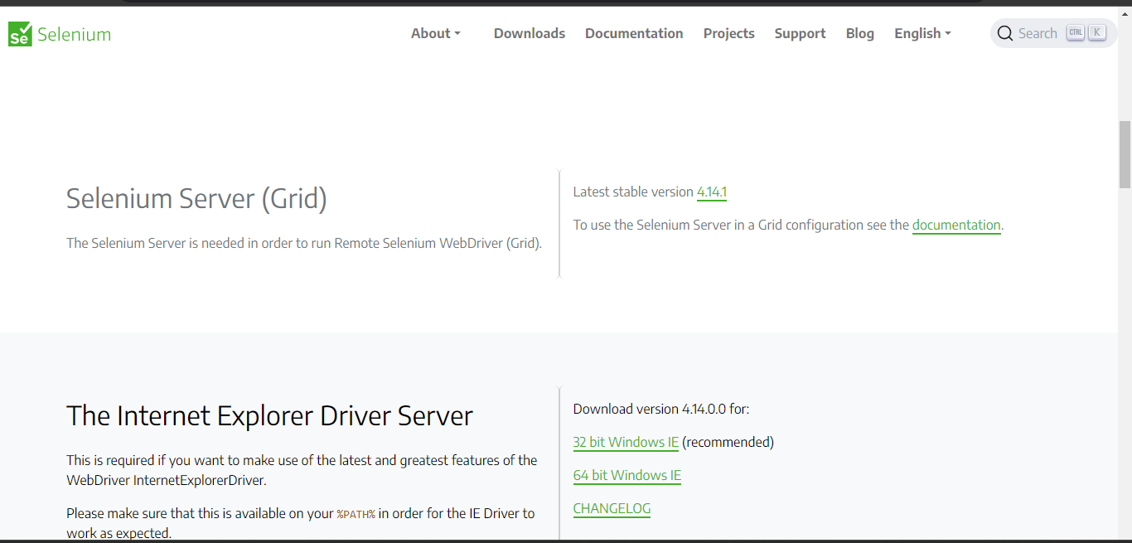

Fig: Installing jar file of Selenium Grid

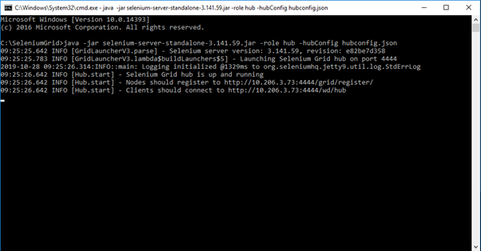

Fig: Hub configuration

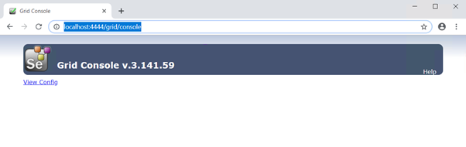

**Fig** Hub is up and running on <http://localhost:4444/grid/console>

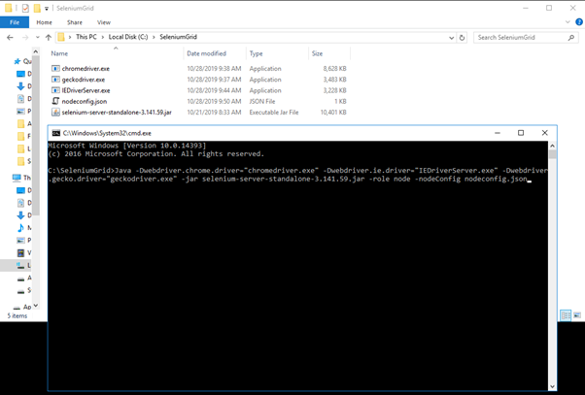

# **Fig Node(s) configuration**

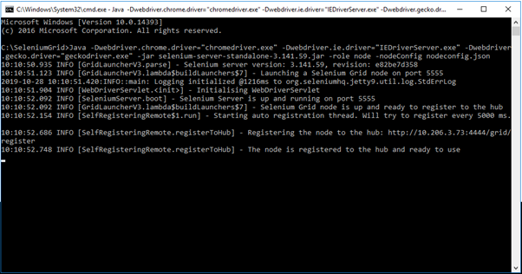

**The node is registered to the hub and ready to use**